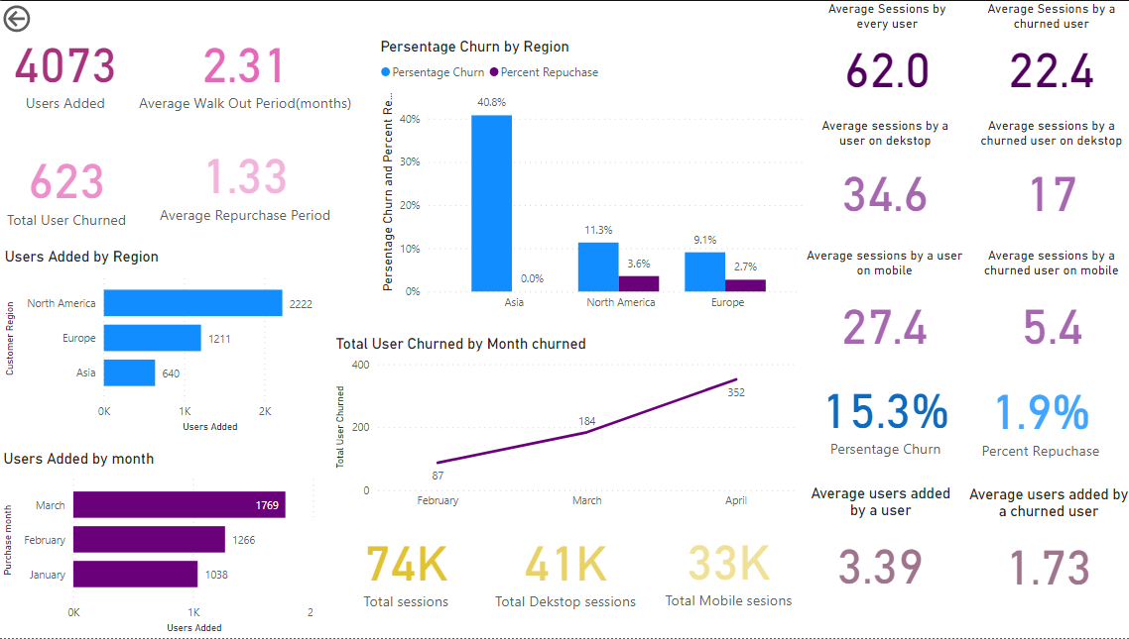

**Page 1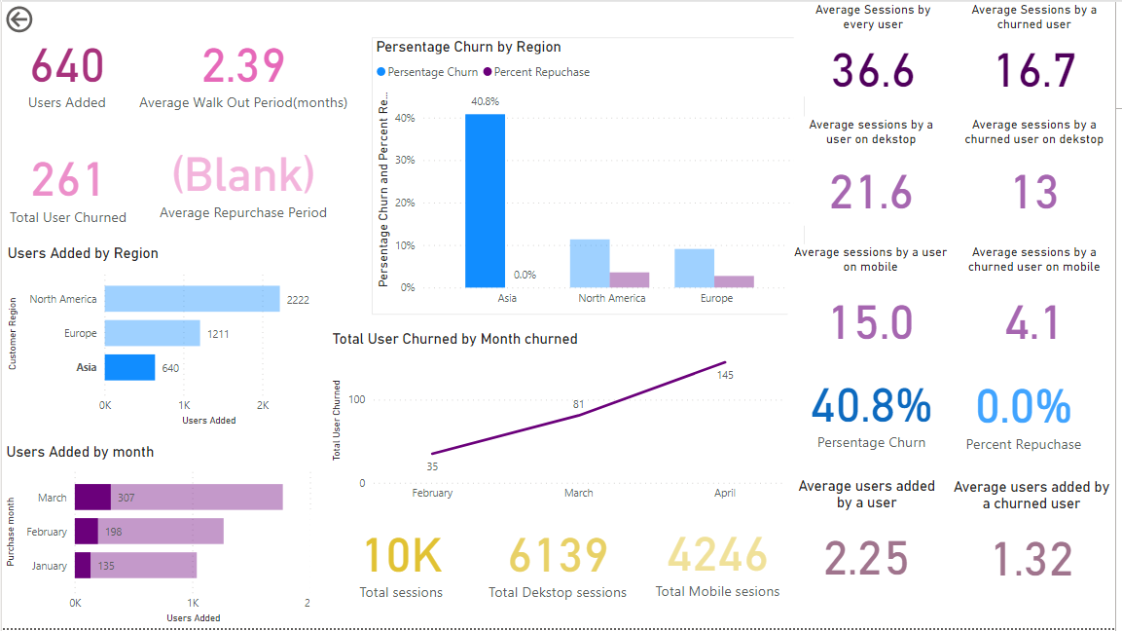Page 2**

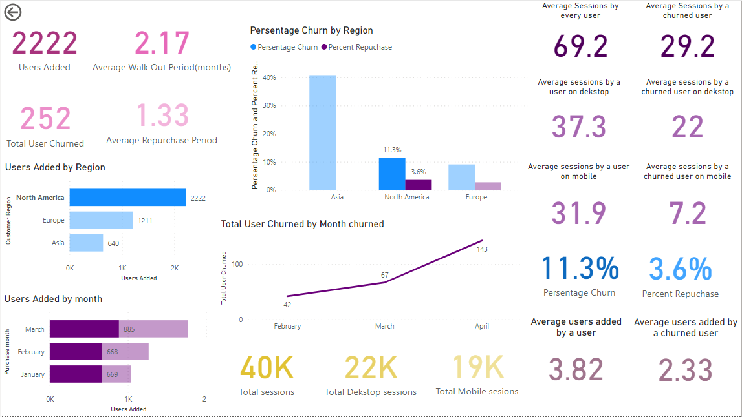**Page 3**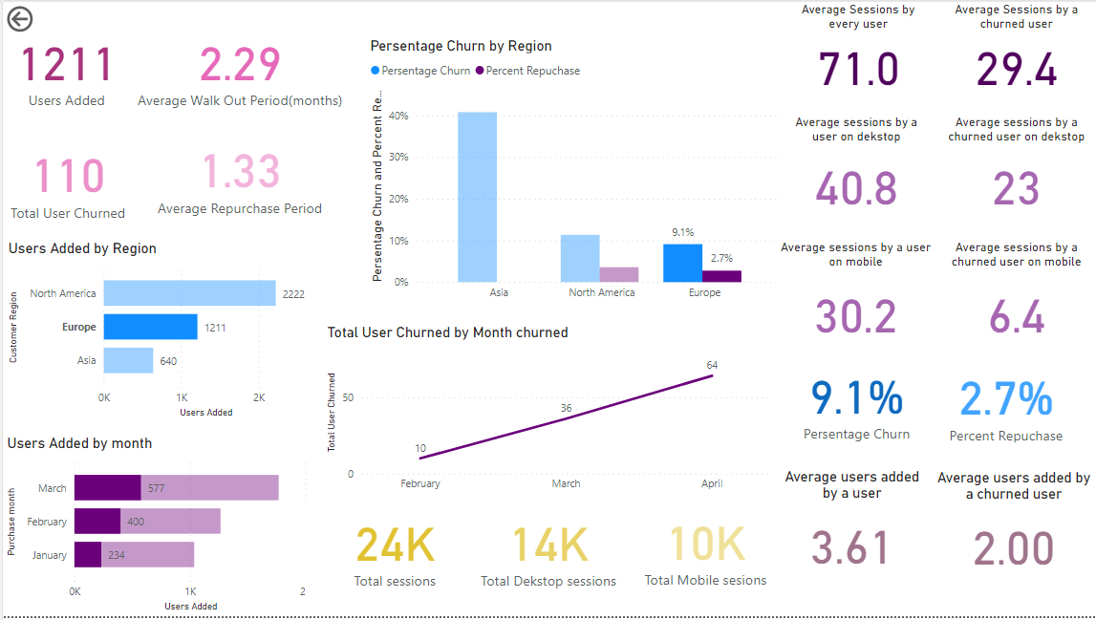

**Page 4**

**Page 1 takeaways**

* The bases that was given in the problem was wrong as it was only considering the number of Customer IDs Churned.

But by taking the actual number of users added per ID that is coming out to be 15.3%.

* The average users added by a churned user was very low at 1.73 per ID as compared to a retained user which is 3.39 per ID which tells us that happy customers are adding more users.
* The Average sessions by churned customer is also very low which is 22.4 per user as compared to 62 for a retained user. From this we can infer that churned users are not able to engage with our service as much, which led then to believe that it’s not worth it for them.

To tackle this we can provide demo/tutorial lectures for our customers so that they could understand the service fully.

* The churn number is increasing per month at an alarming pace.
* In Asia the churn rate is alarming at 40.8%.
* Users repurchasing the service after churning is very low at 1.9%, which means that users are not regretting in moving out of the service and it may also mean that they are finding better services elsewhere.

To tackle this we must analyse our competitors and work on improving the service. We can also take feedbacks from the churned users.

* Churned Users are not engaging much with the mobile app as much, which may be indicating that the presentations provided by the teacher is not suitable to read in the mobile app. We can work on the Presentations to make them mobile friendly

**Page 2 Takeaways (Asia region)**

* Repurchase rate is zero, which means that uses are not coming back hence there is a tough competitor in the market.
* Less Users are added per Customer ID
* The sessions per users is almost half as compared to the global users. Users are using the service less
* Percentage Churn is the highest at 40.8%.
* New Subscriptions are also the least in the three months

In my opinion we should analyse the competition and also the needs of the customers in Asia thoroughly. After words we can release an Asia specifics service to tackle the demand issue.

**Page3 Takeaways (North America)**

* New Subscriptions are maximum in the region and a decent churn out rate of 11.3%
* The repurchase rate is the highest of all the regions.

Over all the North America region is doing great, we can incorporate the strategies used here in the other regions as well.

**Page 4 Takeaways (Europe)**

* Percentage Chur is the least at 9.1%
* Users here are taking the maximum sessions
* Mobile engagement percentage is lowest of all the regions.

Over all Europe is going fine, we should do a research on the mobile behaviours of the users on this region and accordingly we should design our app for them.

I have created the shown Dashboard in Microsoft Power Bi, but due to the sharing restrictions of the free version that I have of Power bi, I couldn’t share the report in Excel file. Although my dashboard in fully functional.